PROJECT REPORT
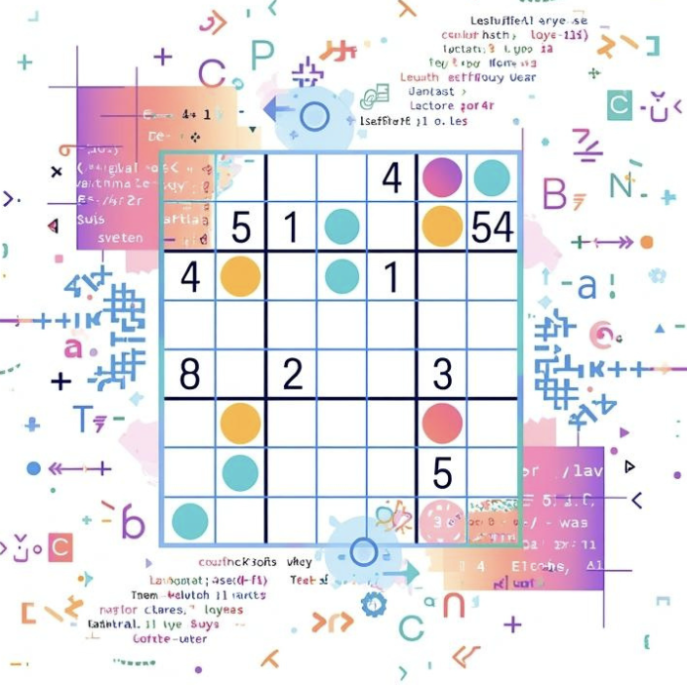
C MINI PROJECT REPORT
4X4 AND 9X9 SUDOKU GAME USING C PROGRAMMING

Submitted by:
Arya Chalikwar (1262251699)
Deetya Panchal (1262251777)
Helly Gandhi (1262250532)
Shambhavi Katyayan (1262252522)

Course: FOUNDATIONS OF PROGRAMMING (C LANGUAGE)
Institution: MIT-WPU
Guide: Dr. Anushri Kulkarni
Submission Date:

ACKNOWLEDGEMENT
We express our sincere gratitude to our respected guide, Dr. Anushri Kulkarni, for her continuous guidance, motivation, and valuable suggestions throughout the development of this project. Her support helped us understand the fundamental concepts of programming and apply them effectively.

We would also like to thank MIT-WPU for providing us with the resources, infrastructure, and learning environment necessary for completing this project successfully.

We extend our heartfelt appreciation to all team members for their collaboration, coordination, and dedication. Working together on this project enhanced our teamwork skills, logical thinking, and practical understanding of programming.

ABSTRACT

Sudoku is a popular logic-based puzzle that requires filling a grid with numbers while satisfying specific constraints. This project presents the design and implementation of a Multi-Grid Sudoku Game using C Programming, capable of supporting different grid sizes such as 4×4 and 9×9.
The primary objective of this project is to develop a system that can generate valid Sudoku puzzles dynamically, allow user interaction, and validate inputs based on Sudoku rules. The project utilizes fundamental programming concepts such as arrays, functions, recursion, and backtracking algorithms to achieve its functionality.
The Sudoku grid is generated using a backtracking technique, which ensures that every puzzle created has a valid solution. After generating a complete solution grid, certain cells are removed randomly to create a playable puzzle. The user is then allowed to input values, which are validated in real-time based on row, column, and subgrid constraints.
The system also includes additional features such as:
- Generation of new puzzles
- Solution display functionality
- Input validation and error handling
- Completion detection with feedback
The implementation of this project highlights the importance of algorithm design and logical structuring in solving complex problems. The use of backtracking ensures correctness but also demonstrates the computational complexity involved in solving such puzzles.
This project not only serves as an educational tool for understanding recursion and problem-solving techniques but also enhances the user’s logical thinking and analytical skills.
In conclusion, the Multi-Grid Sudoku Game successfully demonstrates how fundamental programming concepts can be applied to develop an interactive and functional application in C programming.

TABLE OF CONTENTS

1. Introduction
2. Literature Review
3. Problem Definition
4. System Design
5. Methodology
6. Algorithm
7. Implementation
8. Results and Discussion
9. Testing and Validation
10. Advantages and Limitations
11. Conclusion
12. Future Scope
13. References
14. Appendix

INTRODUCTION
Sudoku is a widely known logic-based number placement puzzle that has gained popularity due to its ability to enhance cognitive skills such as logical reasoning, pattern recognition, and problem-solving. The puzzle consists of a grid where numbers must be placed in such a way that they satisfy specific constraints.
This project focuses on the development of a Multi-Grid Sudoku Game using C Programming, which supports different grid sizes such as 4×4 and 9×9. The system dynamically generates valid Sudoku puzzles, allows user interaction, and validates inputs based on predefined Sudoku rules.
The main objective of this project is to implement core programming concepts such as:
- Arrays
- Functions
- Recursion
- Backtracking algorithms
- Input validation
This project not only demonstrates problem-solving techniques but also strengthens understanding of algorithm design and structured programming in C.

LITERATURE REVIEW
Sudoku has been extensively studied in the fields of mathematics and computer science, particularly in combinatorics and artificial intelligence. Various approaches have been used to solve Sudoku puzzles, including:
- Backtracking Algorithm: A recursive method that tries all possible solutions and backtracks when a constraint is violated.
- Constraint Satisfaction Problems (CSP): Sudoku can be modeled as a CSP where constraints must be satisfied simultaneously.
- Heuristic Methods: Techniques that improve efficiency by reducing search space.
Most modern implementations use high-level languages such as Python and Java, often with graphical interfaces. However, implementing Sudoku in C programming provides deeper insight into:
- Memory management
- Efficient use of arrays
- Low-level algorithm design
This project adopts the backtracking approach, which is simple, reliable, and guarantees a valid solution.

PROBLEM DEFINITION
The objective of this project is to design and implement a system that:
- Generates a valid Sudoku grid of size N×N (where N is a perfect square)
- Removes certain values to create a playable puzzle
- Accepts user input for solving the puzzle
- Validates the input based on Sudoku rules
- Provides options to generate a new puzzle or view the solution
Constraints:
- Each number must appear only once in each row
- Each number must appear only once in each column
- Each number must appear only once in each subgrid
Challenges:
- Generating a valid Sudoku grid dynamically
- Ensuring uniqueness of solution
- Efficiently validating user input
Key Functional Requirements
- The system should generate or display a valid 4×4 or 9×9Sudoku grid with some pre-filled values.
- It should accept user input for empty cells in the grid.
- The program must validate each input based on Sudoku rules (no repetition in rows and columns).
- It should display appropriate messages for valid and invalid inputs.
- The system should indicate when the puzzle is successfully completed.
This problem focuses on combining logical validation with user interaction to create a simple yet effective puzzle-solving application.

SYSTEM DESIGN
The system is divided into multiple functional modules:
1. Input Module
- Accepts grid size (4 or 9)
- Accepts user moves (row, column, number)
2. Generation Module
- Generates a complete valid Sudoku grid using backtracking
- Randomizes numbers to create different puzzles each time
3. Validation Module
- Checks whether the entered number satisfies:
  - Row condition
  - Column condition
  - Subgrid condition
4. Display Module
- Prints the Sudoku board in a structured format
- Displays empty cells using placeholders
5. Control Module
- Manages overall flow of the program
- Handles options like:
  - New game
  - Show solution
  - Exit
Data Structures Used
- 2D arrays for storing Sudoku grid
- Integer variables for grid size and indices
METHODOLOGY
The project follows a systematic approach:
- Initialization
  - User inputs grid size (4×4 or 9×9)
  - Board is initialized with zeros
- Sudoku Generation
  - Backtracking is used to fill the grid with valid numbers
  - Randomization ensures different puzzles each time
- Puzzle Creation
  - Certain cells are removed randomly
  - The remaining cells form the puzzle
- User Interaction
  - User enters row, column, and number
  - Program validates input
- Validation
  - Checks row, column, and subgrid constraints
- Completion Check
  - If all cells are filled correctly → success message
- Game Control
  - User can restart or exit
Validation Rules
- A number must not be repeated in any row.
- A number must not be repeated in any column.
- The entered value must be within the valid range (1–4).
These rules ensure that the Sudoku puzzle is solved correctly.

ALGORITHM
Step-by-Step Algorithm
1 Sudoku Grid Generation Algorithm (Backtracking)
- Start with an empty grid of size N × N
- Select the first empty cell in the grid
- Try placing numbers from 1 to N in the selected cell
- For each number:
  - Check if it is valid in the current row
  - Check if it is valid in the current column
  - Check if it is valid in the corresponding subgrid
- If the number is valid:
  - Place the number in the cell
  - Move to the next empty cell
- If no number is valid:
  - Backtrack to the previous cell
  - Replace the previous value with another possible number
- Repeat the process until all cells are filled
- The result is a fully solved Sudoku grid

2 Sudoku Validation Algorithm
- Accept row, column, and number as input
- Check the entire row for duplicate values
- Check the entire column for duplicate values
- Identify the corresponding subgrid
- Check the subgrid for duplicate values
- If the number is not found in row, column, or subgrid:
  - Accept the number
- Otherwise:
  - Reject the number as invalid

3 Puzzle Creation Algorithm
- Generate a complete valid Sudoku grid
- Decide the number of cells to remove
- Select random row and column positions
- Replace the selected cells with zero (empty)
- Repeat until required number of cells are removed
- Display the modified grid as the puzzle

4 User Input Handling Algorithm
- Accept user input (row, column, number)
- Check if the input is within valid range (1 to N)
- Check if the selected cell is empty
- Validate the entered number using Sudoku rules
- If valid:
  - Place the number in the grid
- If invalid:
  - Display error message
- Provide options for:
  - New game
  - Show solution
  - Exit

5 Completion Checking Algorithm
- Scan all cells of the grid
- Check if any cell contains zero (empty)
- If any empty cell is found:
  - Puzzle is incomplete
- If no empty cells are found:
  - Puzzle is complete
- Display congratulatory message

6 Solution Display Algorithm
- Store the fully solved Sudoku grid
- When user requests solution:
  - Access stored solution
- Display the complete grid
- Allow user to continue or start new game

IMPLEMENTATION
The project is implemented using C programming language with the following components:
Functions Used:
- generateSudoku() → Generates puzzle
- fillGrid() → Uses backtracking
- isValid() → Validates input
- removeDigits() → Creates puzzle
- printBoard() → Displays grid
- isComplete() → Checks completion
Concepts Applied:
- Recursion
- Backtracking
- Arrays
- Conditional statements
- Looping constructs
The program ensures modularity and readability by dividing tasks into functions.

RESULTS AND DISCUSSION
The developed program was tested with various inputs and successfully performed all required operations.

Observations
- The system accurately validates user inputs based on Sudoku rules.
- Invalid entries are detected and appropriate error messages are displayed.
- The grid updates dynamically after each valid input.
- The user can clearly track progress throughout the game.

Performance
The program executes efficiently due to its small grid size and simple validation logic. It requires minimal memory and processing time, making it suitable for basic systems and educational use.

TESTING AND VALIDATION
The system was tested using different test cases to ensure correctness and reliability.
Test Case | Input | Expected Output | Result
Valid Entry | Unique number | Accepted | Pass
Duplicate Row | Same number | Error | Pass
Duplicate Column | Same number | Error | Pass
Invalid Input | >4 or >9 | Error | Pass

The results confirm that the program behaves correctly under different scenarios and handles errors effectively.

ADVANTAGES AND LIMITATIONS
Advantages
- Enhances logical thinking
- Uses efficient backtracking algorithm
- Modular and structured code
- Supports multiple grid sizes
- Interactive gameplay
Limitations
- Console-based interface
- Performance decreases for large grids
- No difficulty level customization
- No graphical visualization
CONCLUSION
This project successfully demonstrates the implementation of a multi-grid Sudoku game using C programming. It integrates important programming concepts such as recursion, arrays, and validation techniques.
The use of backtracking ensures that generated puzzles are valid and solvable. The project serves as a strong example of applying algorithmic thinking to real-world problems.

FUTURE SCOPE
The project can be further enhanced by:
- Adding difficulty levels
- Implementing graphical interface
- Adding timer and scoring system
- Supporting larger grids (16×16)
- Incorporating AI-based hints

REFERENCES
- GeeksforGeeks – Sudoku Solver
- Programming in C by Dennis Ritchie
- Online tutorials and academic resources

APPENDIX
Sample Output
1 0 0 4
0 3 0 0
0 0 2 0
2 0 0 1

Additional Notes
- The program can be extended to support larger grids.
- Additional features like GUI and database can be integrated.

